Investing a Percentage of Your Income (I) - Corrected Full Answer
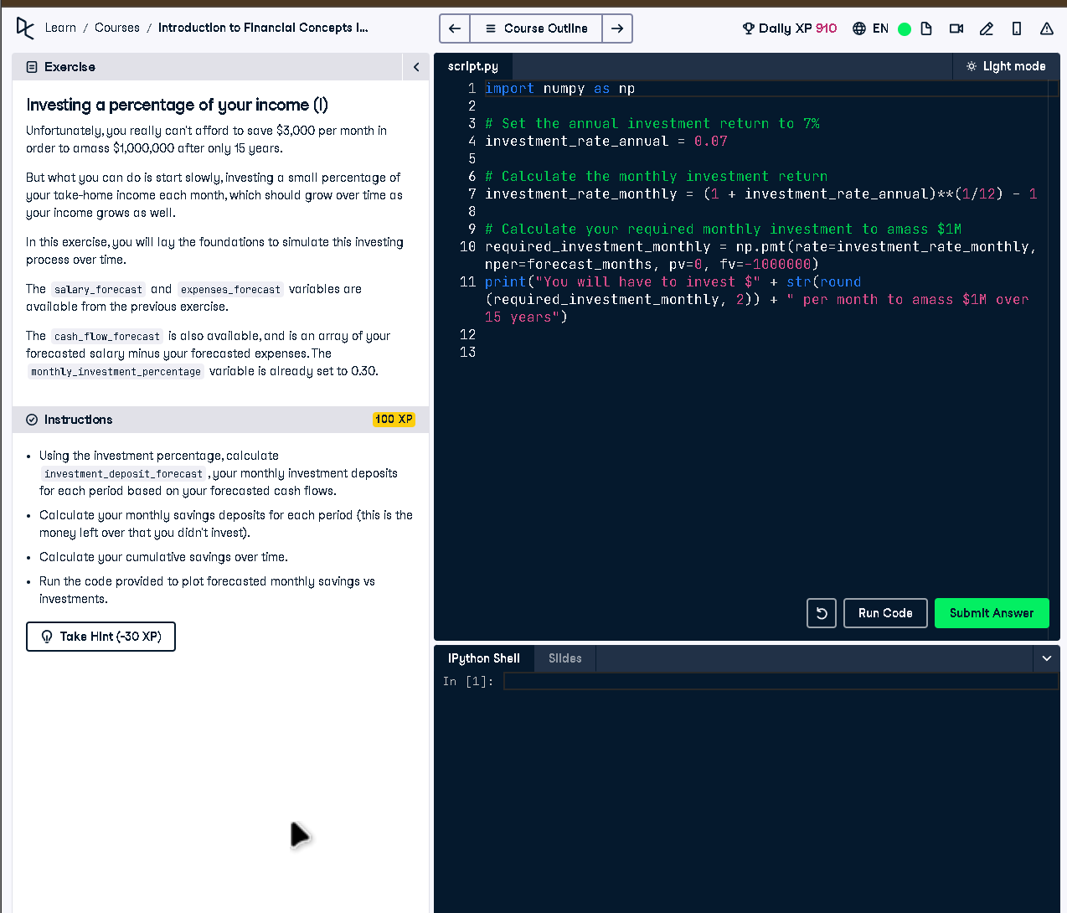

Full Code Answer:
import numpy as np
# Calculate your monthly deposit into your investment account
investment_deposit_forecast = cash_flow_forecast * monthly_investment_percentage
# The rest goes into your savings account
savings_forecast_new = cash_flow_forecast * (1 - monthly_investment_percentage)
# Calculate your cumulative savings over time
cumulative_savings_new = np.cumsum(savings_forecast_new)
# Plot your forecasted monthly savings vs investments
plt.plot(investment_deposit_forecast, color='red')
plt.plot(savings_forecast_new, color='blue')
plt.legend(handles=[investments_plot, savings_plot], loc=2)
plt.show()

Question:
How do you calculate and compare monthly investments and savings when investing a fixed percentage of income?

20-word Explanation (Question):
Investment and savings split is calculated by distributing cash flows based on a fixed investment percentage every month.

Answer:
Multiply cash_flow_forecast by monthly_investment_percentage for investments, allocate the rest to savings, and plot both for comparison.

20-word Explanation (Answer):
The remaining income after investments is saved, while cumulative tracking and plotting provide visual insights into growth patterns.

